Control Engineering II

Handout – Online Laboratory 2

Name: *Colda Andreea Ariana*

Group: *30332*

For the process transfer function:



solve the following problems:

1. Tune a PD controller for the process that ensures a phase margin of γk= 60o

*Add PD controller here.*

*6.769 s + 1.884*

*Hc = ---------------*

*0.3593 s + 1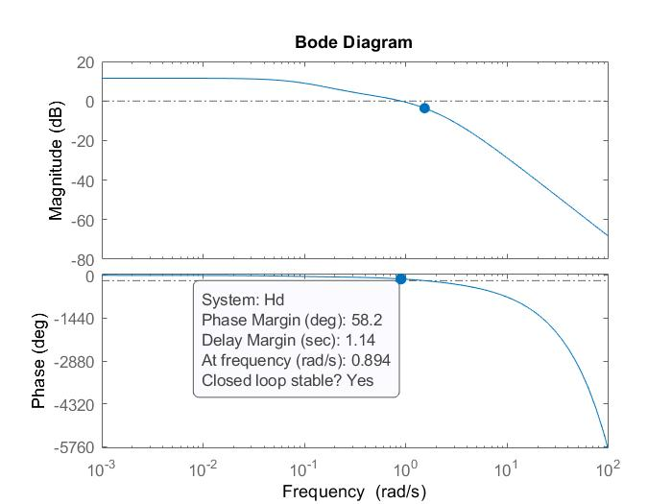*

1. Select a proper sampling period and obtain the digital controller using zero-order-hold method

*Add sampling period and motivate its choice.*

The smalles time constant is 0.3593 => the sampling period will be 2 times smaller than the smallest time constant => Ts = 0.1

1. Design the Simulink block diagram of the closed loop system with the analog PD controller and simulate the output response to a step change in the reference signal w
2. Design the Simulink block diagram of the closed loop system with the digital controller and simulate the output response to a step change in the reference signal w
3. Compare the performance of the two controllers in terms of overshoot and settling time

*Add plot here.*

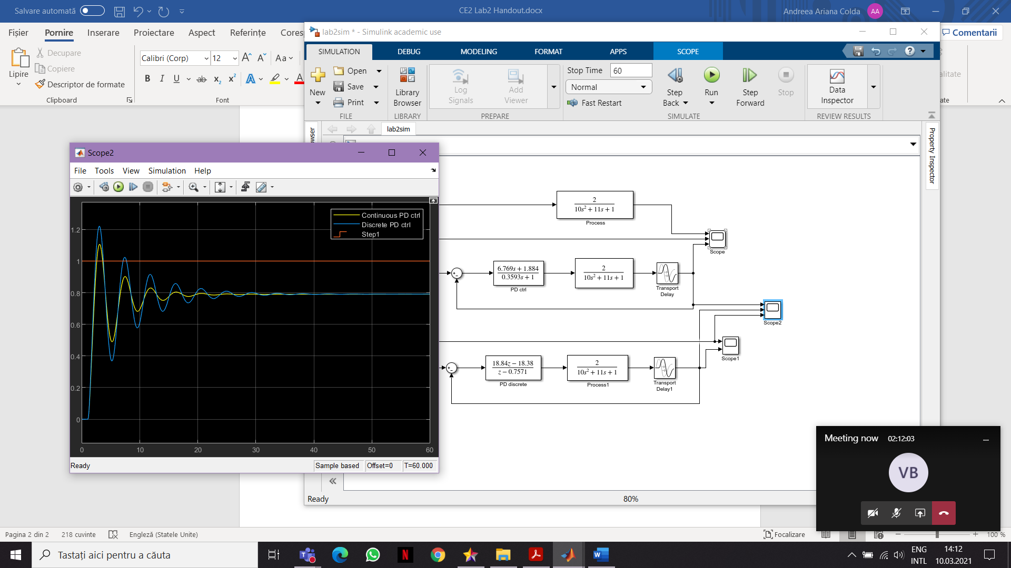

*For the discrete one the overshoot is 0.4(40%) and for the continuous time is 0.3(30%). In terms of settling time we can say that the continuous PD ctrl settles more rapidly than the discrete one. For the continuous PD ctrl the settling time is around 28 sec and for the discrete PD ctrl is around 50 sec.*

1. Redesign the digital controller (by choosing a different sampling period) and evaluate the closed loop performance result

*Add plot here. What is the new sampling period?*

*Ts = 0.01*

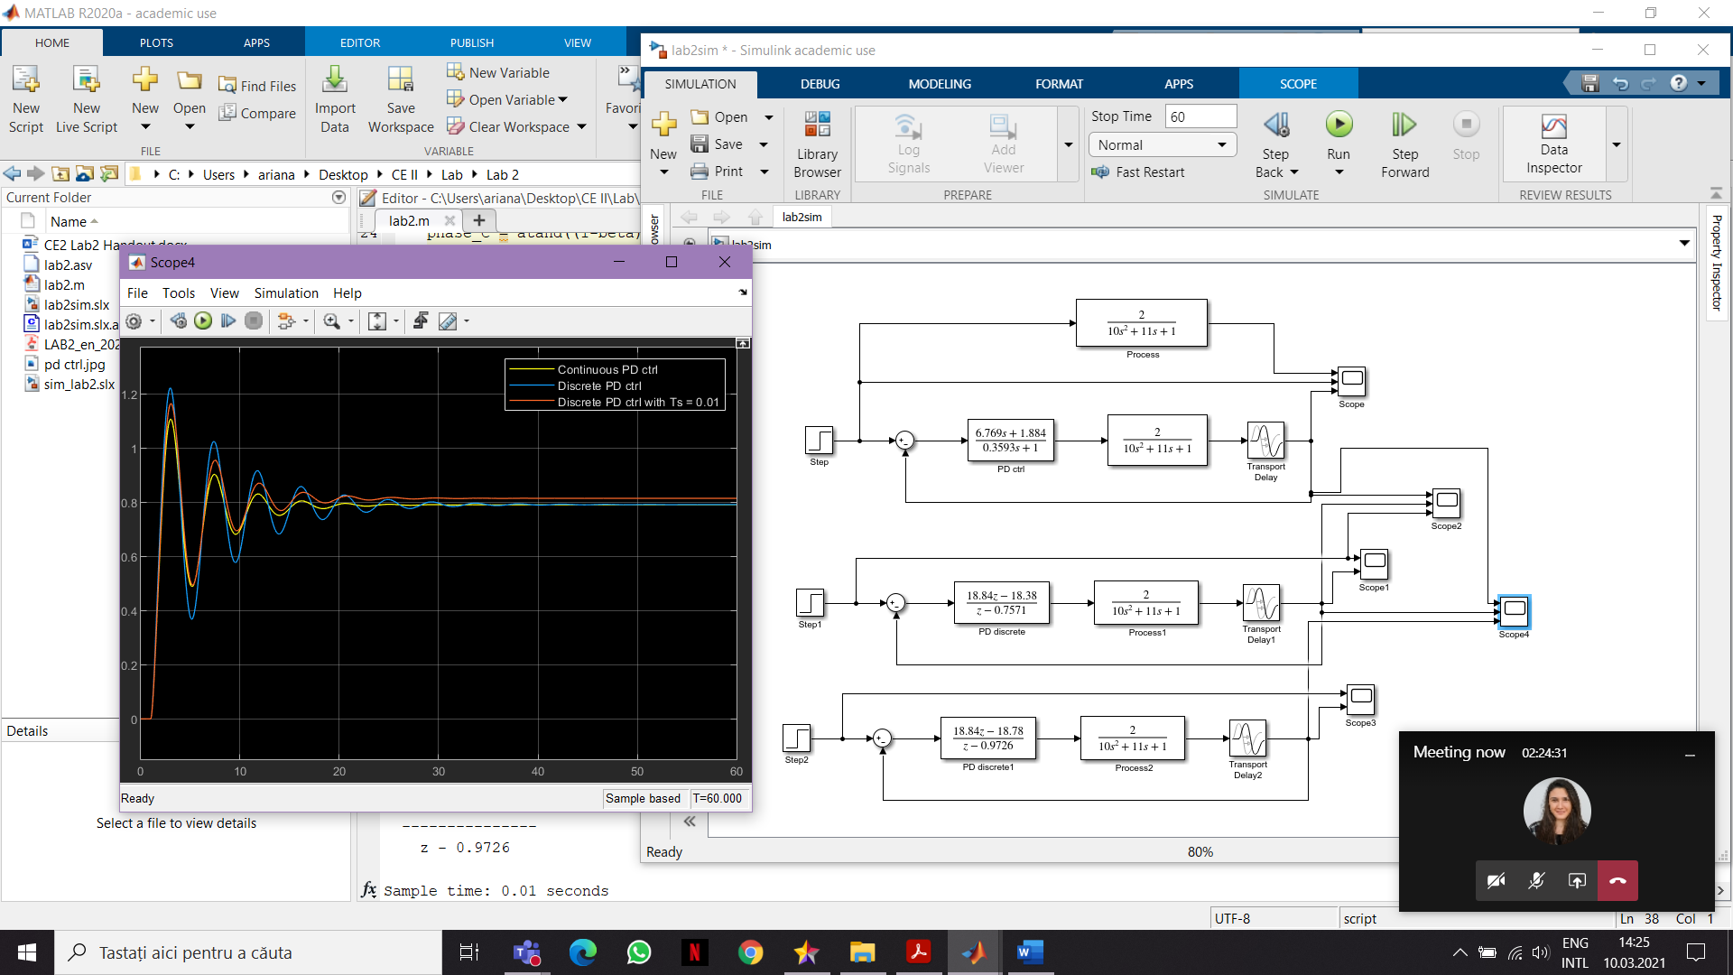

*We can see that for the PD ctrl with a smaller sampling time the settling time and the overshoot are smaller than the continuous PD ctrl and the discrete PD ctrl with Ts = 0.1. And the discrete PD ctrl with Ts = 0.01 is more similar with the continuous PD ctrl.*

1. For the final digital controller, determine the control signal recurrence relation

